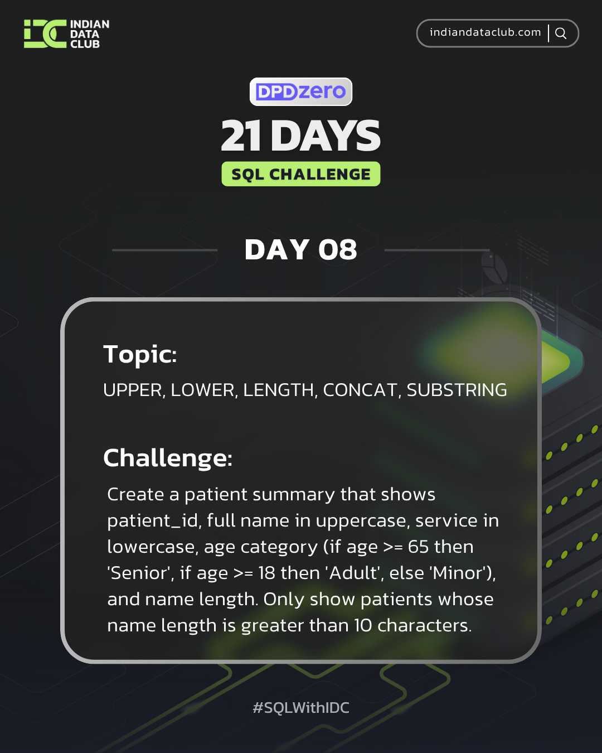

Day-8 SQL Challenge
Day-8 Challenge:
Create a patient summary that shows patient_id, full name in uppercase, service in lowercase, age category (if age >= 65 then 'Senior', if age >= 18 then 'Adult', else 'Minor'), and name length. Only show patients whose name length is greater than 10 characters.
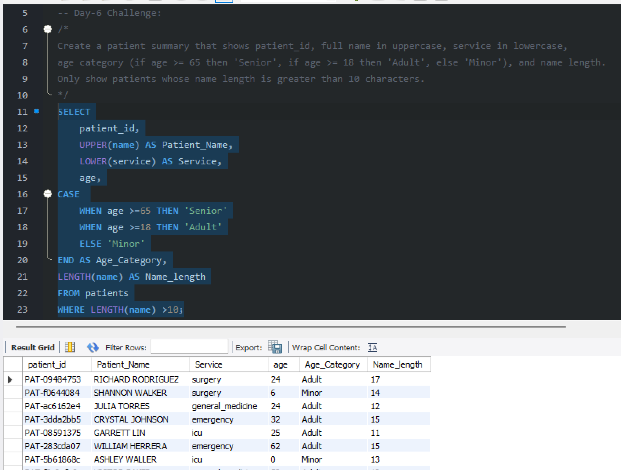

Practice Questions:
1. Convert all patient names to uppercase.
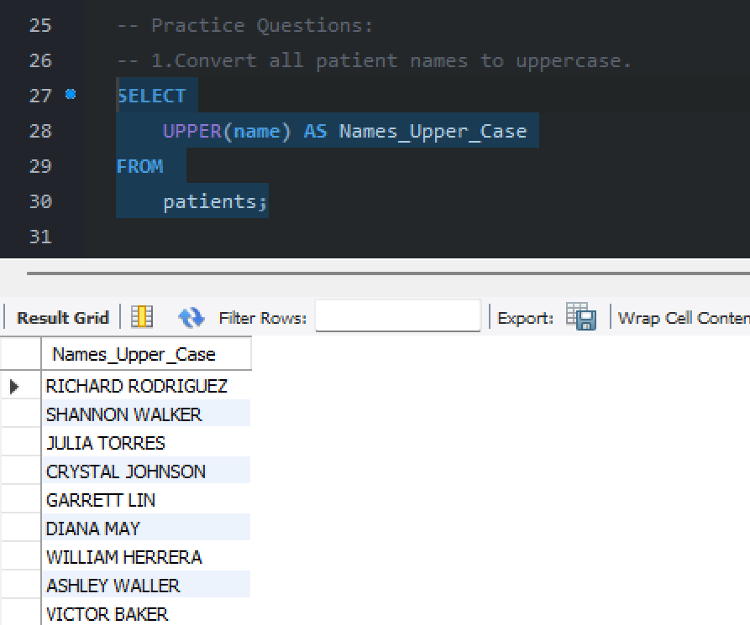
2. Find the length of each staff member's name.
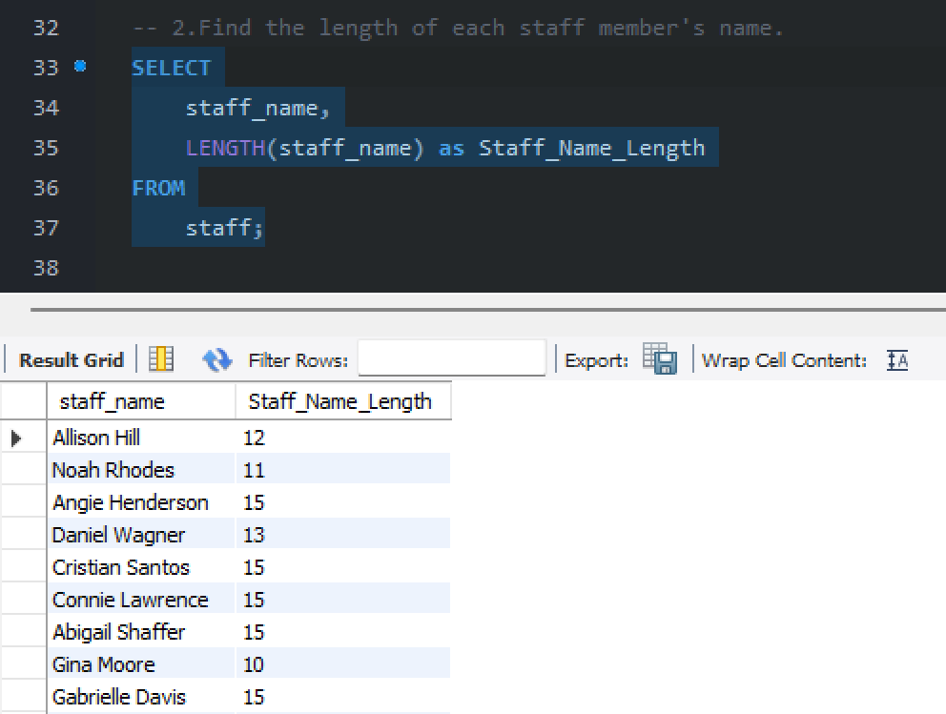

3. Concatenate staff_id and staff_name with a hyphen separator.
